1 Introduction 1
2 Scope and field of application 1
3 Definitions and Abbreviations 1
4 User Interface 2
4.1 Clarity is job #1 2
4.2 Familiarity 2
4.3 Efficiency 2
4.4 Consistency and structure 2
4.5 One primary action per screen 2
4.6 Keep secondary actions secondary 2
4.7 Provide a natural next step 2
4.8 Look and Feel 3
4.8.1 Examples / inspiration 3
4.8.2 EmonCMS 3
4.8.3 Dashboard example Northstar: 5
4.8.4 Dashboard example iDean: 5
4.8.5 Example existing MSM ( wrong colors in mainview) 7
4.8.6 Eltek color palette 8
4.9 Menu 8
4.10 Button 8
4.11 Tab 8
4.12 Grid 8
4.13 Multigraph /DataViewer 8
4.14 Workflow 9
4.15 Restrictions and limitations 9
4.16 Screensize & screen property 9
4.17 Anticipate mistakes 9
4.18 Give feedback—fast 9
5 Performance 9
5.1 Lazy loading 9
5.2 Progress bar 9
5.3 Always build for scalability 9

DOCUMENT CHANGE RECORD

Rev. | Date | Author | Nature of revision
1.0 | 09.11.2017 | Tonny Mastad | Initial Revision
1.1 | 24.01.2018 | Tonny Mastad | Added look and feel and scalability

Introduction
This document gives information about important points to evaluate during User interface development for Multisitei Monitor.
It also includes a list of important elements that all developers should consider when planning a User Story, and before sending the US to test.

Scope and field of application

Definitions and Abbreviations
MSM - Multisite Monitor
REST - Representational State Transfer
JSON - Java Script Object Notation
Microservice - Implementation approach to build flexible, independently deployable software systems.
UI - User Interface
UX - User eXperience

User Interface

Clarity is job #1
Clarity is the first and most important job of any interface. To be effective using an interface you've designed, people must be able to recognize what it is, care about why they would use it, understand what the interface is helping them interact with, predict what will happen when they use it, and then successfully interact with it. While there is room for mystery and delayed gratification in interfaces, there is no room for confusion. Clarity inspires confidence and leads to further use. One hundred clear screens is preferable to a single cluttered one.

At any place in your app, a few things should be perfectly clear to the user:
• What just happened
• Where you are
• What you can do
• What will happen when you do it
• What just happened, etc.—rinse and repeat

Familiarity
Our eyes love seeing simple and familiar things. Research shows that people even consider them more beautiful.
You should spend less time reinventing a wheel, and use common solutions without feeling guilty.
Second, conventional layouts will seem less complex just because they’re familiar.

Efficiency
Make sure the user completes their main task in the most efficient way and never loses the result of their work.
First, answer a question: what’s the most routine job that the user does on a daily basis? Is it content entry, editing, or viewing? Is it performing the same complex sequence of actions?
Then design the interface to facilitate these tasks in the best way. Measure the effort that’s required to complete the task, like number of clicks, forms, and screens. Then clean up this sequence to make it streamlined.
There’s nothing bad about designing powerful software, but the core interface should be simple and functional. You can always hide plenty of options somewhere in context menus or app settings.

Consistency and structure
Consistency is a way to start feeling familiar about certain things, even if they were unknown before. It’s a way to introduce your own language inside the app. Structure makes things more approachable, without feeling messy or overwhelming.

Here’s what you can do:
- Introduce strong visual hierarchy, with the most important things big and bold
- Align everything nicely along the grid, or introduce any other kind of visual order
- Use a consistent color scheme throughout the app
- Keep the navigation consistent across all screens
- Re-use the same elements for different situations. For example, design a sample notification and color-code it for different situations.
Consistency and structure will help the user feel at home. And that’s what we want.

One primary action per screen
Every screen we design should support a single action of real value to the person using it. This makes it easier to learn, easier to use, and easier to add to or build on when necessary. Screens that support two or more primary actions become confusing quickly. Like a written article should have a single, strong thesis, every screen we design should support a single, strong action that is its raison d'etre.

Keep secondary actions secondary
Screens with a single primary action can have multiple secondary actions but they need to be kept secondary! The reason why your article exists isn't so that people can share it on Twitter…it exists for people to read and understand it. Keep secondary actions secondary by making them lighter weight visually or shown after the primary action has been achieved.

Provide a natural next step
Very few interactions are meant to be the last, so thoughtfully design a next step for each interaction a person has with your interface. Anticipate what the next interaction should be and design to support it. Just as we like in human conversation, provide an opening for further interaction. Don't leave a person hanging because they've done what you want them to do…give them a natural next step that helps them further achieve their goals.

Look and Feel
The user interface should be clean and modern. Using the Eltek colour palette.

Examples / inspiration
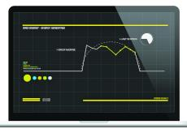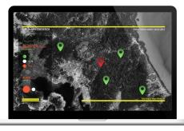
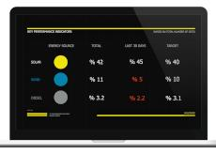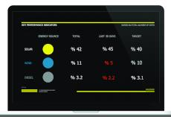

Eltek color palette
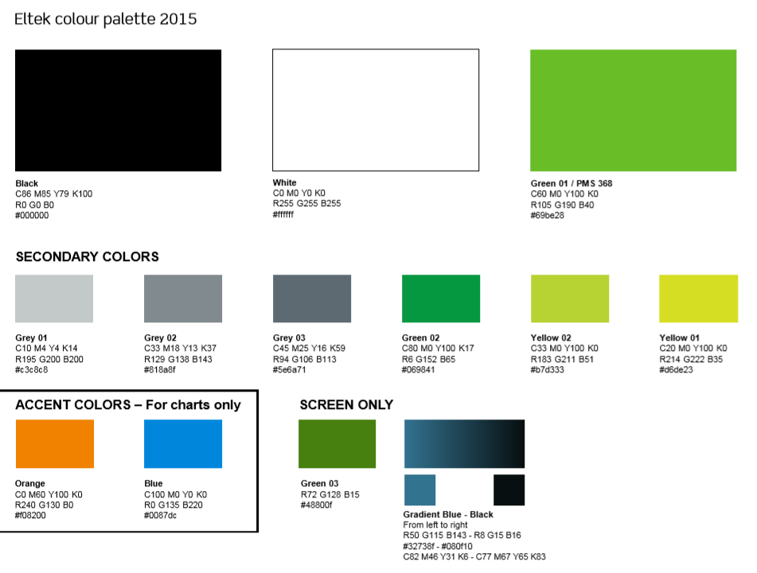

Menu
Standarize: TODO: Show example

Button
Standarize: TODO: Show example

Tab
Standarize: TODO: Show example

Grid
Should use standard grid in all views where a grid is needed. Should contain advanced filtering, short on several columns and paging as standard. Paging should be user defined and show page and total pages, first, last, next and previous.

Multigraph /DataViewer
Should be used everywhere where multigraph is needed.
- Able to show timeseries data
- Filter on “from time” and “to time”
- Show highest/lowest
- Show average
- Show multiple timeseries in the same graph.
- Scale axis automatically or manually
- Easy zoom (click and drag pointer for zooming)
- Labels
See EmonCMS dataviewer : https://github.com/emoncms/graph

Workflow
Make sure there is a natural workflow to other related pages/data in the application
Check that all links/navigation etc are natural and give good information about what happens when you use it.

Restrictions and limitations
Make sure the correct access rights to all feature on the page is evaluated and approved.
Make sure the correct access rights to all data on the page is evaluated and approved.

Screensize & screen property
Rely on traditional design solutions that work well in different situations (simple responsive layouts, less things stuffed in corners)
Make sure the data is evenly and neat positioned in a tasteful way on te screen property.
Check that it sizes correctly. Account for all the devices and resolutions
Think through all the possible content situations (no content, little content, ugly content, weird content). Sketch up the most important ones.

Fitts’ Law, a fundamental principle of human-computer interaction (HCI), states that:
The time to acquire a target is a function of the distance to and size of the target.
In other words: the closer and/or bigger something is, the faster you can put your cursor (or finger) on it. This obviously has all kinds of implications for interaction and UI design, but three of the most important are:
Make buttons and other “click targets” (like icons and text links) big enough to easily see and click. This is especially important with menus and other link lists, as insufficient space will leave people clicking the wrong links again and again.
Make the buttons for the most common actions larger and more prominent.
Place navigation (and other common interactive elements, like search bars) on the edges or corners of the screen. This last might seem counterintuitive, but it works because it lessens the need for accuracy: a user doesn’t need to worry about overshooting their click target.
While you’re thinking about element placing and size, always keep your interaction model in mind. If your site requires horizontal scrolling rather than vertical scrolling, you’ll need to consider where and how to cue users to this unusual interaction type.

Anticipate mistakes
People make mistakes, but they shouldn’t (always) have to suffer the consequences. There are two ways to help lessen the impact of human error:
- Prevent mistakes before they happen
- Provide ways to fix them after they happen

Give feedback—fast
All too often, digital interfaces fail to give much back, leaving us wondering whether we should reload the page, restart the laptop, or just fling it out the nearest available window.
So give me that loading animation. Make that button pop and snap back when I tap it—but not too much. And give me a virtual high-five when I do something you and I agree is awesome.

Just make sure it all happens fast. Usability.gov defines any delay over 1 second as an interruption. Over 10 seconds, a disruption. And the latter’s generous: for about half the U.S. population, 3 seconds is enough to cause a bounce.
If a page will load in under 5 seconds, don’t display a progress bar, as it’ll actually make the loading time seem longer. Instead, use a visualization that doesn’t imply progress, like Mac’s infamous “pinwheel of death.” But not that. If you do use progress bars on your site, consider trying some visual tricks to make the load seem faster.

Performance

Lazy loading

Progress bar

Always build for scalability
MSM should be able to show data from 50 000 sites. This needs to be done in a smart way. Thousands of visual elements laded on a page at the same time is not necessary. We should use smart filtering/sorting and queries. How many alarms can be showed in a view? Could we group the visual elements better? Same types of alarms, sites, configurations, etc. Most important is that it is easy to find the information you are looking for within the data from all the 50 000 sites.

